**Corrections to the first edition of *The Word of the Lord* book**

We apologize for these errors in the first edition printing of *The Word of the Lord* books. If you are leading a group working through the study, please provide these corrections to your group members.

Page 39: In question 7 the first part of the question should be:  What Jonah did:

Page 41: The reference in the third box should be: Luke 9:43-44, 51-53

Page 65: Question 9 should be: What did Hosea do, according to Hosea 3:2-3?

Page 66: In box four of the chart comparing Hosea’s bride and Christ’s bride, the reference, 2 Cor. 6:20 should be 1 Cor. 6:20.

Page 118: The second reference in the list should be Isaiah 7:14 rather than 7:4.

Page 164: the map should be Map 7 "The Assyrian and Babylonian Empires" from the back map section in the ESV Study Bible

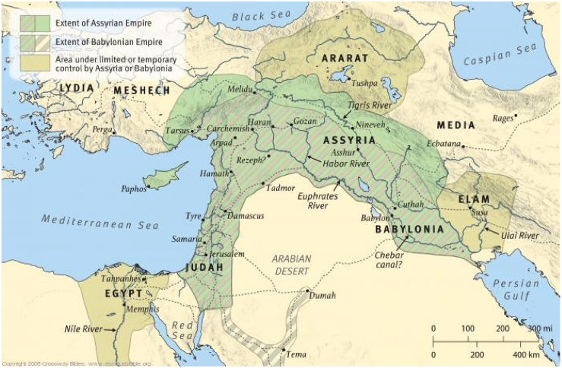

Page 166: The fourth reference in the list should be Jeremiah 2:20-22.

Page 169: In the Promises line of the Old Covenant vs. the New Covenant chart, the Hebrews reference should be: 9:12, 15.